**Central Limit Theorem**

Distributions can be any shape – Normal, skewed or uniform

* We sample the population by selecting values.
* Sample size “n”
* For each sample, we can calculate the mean, variance, standard deviation…
* If I choose every possible sample of size “n” from population
  + Get a “sampling distribution”
* If we can calculate mean of the every sample
  + Get “sampling distribution mean”

**CLT**

**Given**: A population with the mean of µ

And Standard Deviation σ

**Sample**: Choose all samples of size “n” from population

Poplulation distribution diagram:

Samples:

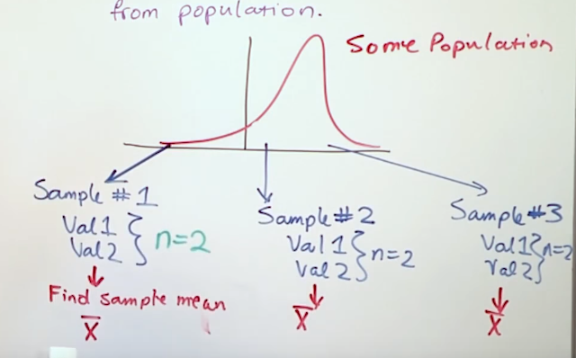

**CLT Theorem:**

The mean of the sample means = mean of the population

µXbar = µ

σ = σ /sqrt(n)

If population is normal, then the sample mean will have a normal distribution ( Independent of sample size).

If population is not normal, but sample size “n” > 30, then sampling distribution of sample means approximates a normal distribution FOR ANY POPLUATION DISTRIBUTION SHAPE.

e-g IQ of the students.